New horizons for advanced robotics at automatica 2023:
The HEIDENHAIN KCI 120 Dplus inductive dual encoder

Discover a single device that provides position feedback from both the motor shaft and gearbox output shaft of a robot joint: the HEIDENHAIN KCI 120 Dplus dual encoder. Using robust inductive scanning technology, the encoder’s scanning head reads two separate circular scales for dual feedback. By measuring the gearbox output shaft, the KCI 120 Dplus can counteract design-induced inaccuracy on highly articulated and dynamic robots.

To ensure compatibility with as many applications as possible, the dual encoder comes in three variants featuring different hollow-shaft sizes and mounting dimensions for the scanning unit and two disk/hub assemblies. All three versions of the KCI 120 Dplus are compact, easy to integrate and equal in functionality.

The innovative KCI 120 Dplus widens the horizon of robot applications, making even high-accuracy machining tasks possible. And thanks to its EnDat 2.2 serial data interface, which is designed for functional safety, this dual encoder also thrives in safety-critical applications such as cobots.

Visit HEIDENHAIN at automatica 2023 in Munich: Hall B6, Booth 303

For more information, see:
robotics.heidenhain.com
www.heidenhain.de

Person of contact for trade press:
Ulrich Poestgens
Tel.: +49 8669 31-4154
poestgens@heidenhain.de

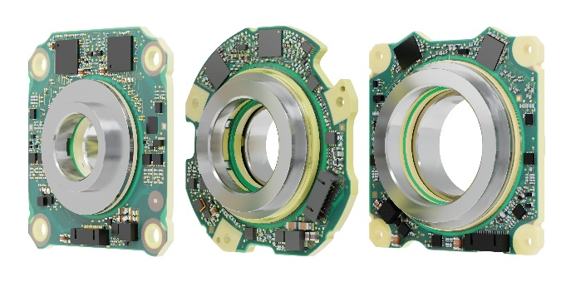 | Available in three variants, the HEIDENHAIN KCI 120 Dplus dual encoder provides position feedback from both the motor shaft and gearbox output side of a robot joint, making it ideal for advanced robotics applications.

